# Online Jewellery System

**User Stories**

1. As a customer, I want to easily browse and search for jewelry items on the website, so that I can quickly find what I am looking for.
2. As a customer, I want to be able to view high-quality images of the jewelry items, so that I can get a clear idea of what they look like before making a purchase.
3. As a customer, I want to see detailed product descriptions and specifications, so that I can make an informed decision about my purchase.
4. As a customer, I want to be able to filter my search results by various criteria such as price type, etc., so that I can find exactly what I am looking for.
5. As a customer, I want to be able to add items to my shopping cart and easily check out, so that I can make a purchase without any hassle.
6. As a customer, I want to be able to leave reviews and ratings for the jewelry items I purchase, so that other customers can benefit from my experience.
7. As a customer, I want to be able to easily contact customer support for any questions or concerns I may have about my purchase.
8. As a returning customer, I want to be able to easily view my purchase history and reorder items, so that I can quickly purchase items I have bought before.
9. As a customer, I want to be able to take advantage of special offers, discounts, and promotions, so that I can save money on my purchases.

**Tasks For the Next Two Weeks**

1. We will make the admin login process.
2. We will make update functionality of price.

**Use case diagram**

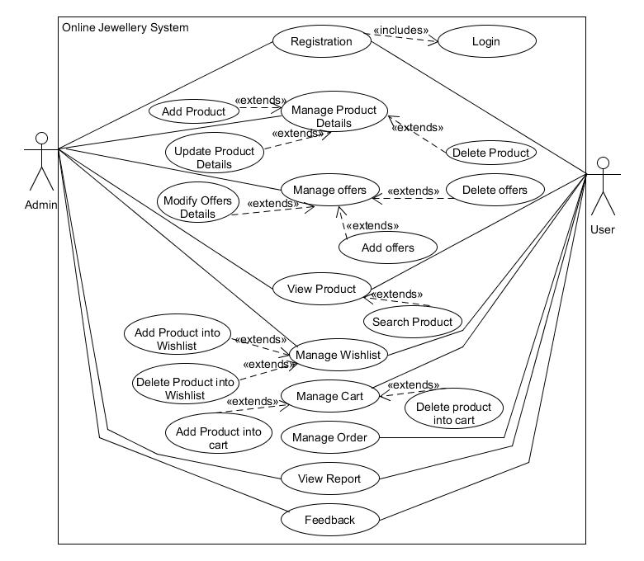

**Sequence Diagram**

